Assignment 4

Exercise 8: Fit some of the non-linear models investigated in this chapter to the Auto data set. Is there evidence for non-linear relationships in this data set? Create some informative plots to justify your answer.

Answer:

Yes, this data has non-linear data in this dataset as seen the below correlation graph:

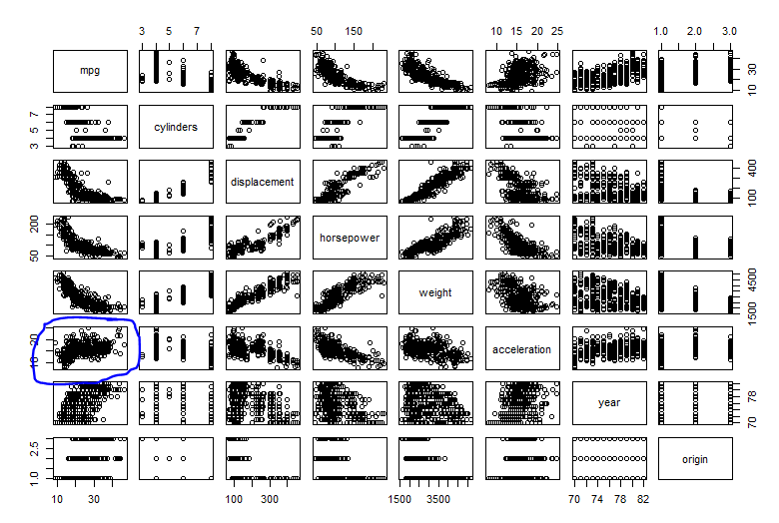

Here, I took Acceleration to go ahead with the model building as it looks non-linear in relationship with mpg.

I created non- linear models and with mpg and acceleration as seen below:

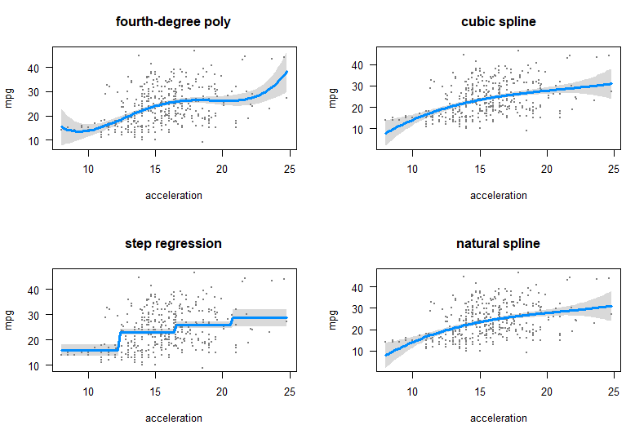

The RMSE for these models came out to be

`lm`

[1] 7.062126

$poly

[1] 6.912593

$step

[1] 7.165128

$cspline

[1] 6.991648

$nspline

[1] 6.906824

The Lease came out to be for nspline.

GAM performed very well with spline on acceleration and year and weight as basic linear regression and gave an RMSE of 3.14.

The GAM with all the predictors excluding name with GAMSpline method gave the best RSME with 3 splines as 2.785.